ECET 230 Practical Final

Name: Tony Biccum

Please complete this document and include a copy in your project. Estimate your mark in each section. Save a copy with all the project files to a directory called YourFullName230Exam. Include all visual studio or unity project code. Include firmware if you made any preapproved changes. ZIP this directory and put it in D2L drop box. Only ZIP files will be excepted.

1. In this section describe your project in detail and include screen shots. Describe the most challenging part of your project. (5 / 5marks)

My project is similar to our meadow lab where we transmitted packets from our mini solar power plant over a serial protocol to a WPF application. What mine does different is instead of using serial protocol I am utilizing the ESP32 co-processor on the meadow board to send packets wirelessly. This was very challenging as the meadow is a newer board so there isn’t much documentation on WiFi communication. The meadow firmware was also difficult as I had to correct a bug effecting the debug files not building correctly. The hardest part by far was finding what libraries to use within the WPF application in order to receive packets on a separate thread.

1. List links for the reference material that you found useful for your project. Comment all code clearly and include links and attributions for any code that you learned about from another source. (5 / 5marks)

<https://docs.microsoft.com/en-us/dotnet/api/system.net.sockets.udpclient?view=net-6.0>

<http://developer.wildernesslabs.co/docs/api/Meadow/Meadow.Gateway.WiFi.html>

<https://docs.microsoft.com/en-us/dotnet/api/system.net.sockets.udpclient.receive?view=net-6.0>

1. Intuitive well designed Graphical User Interface. (9 / 10marks)

Added the ability to change IP and PORT for the receiving UDP server.

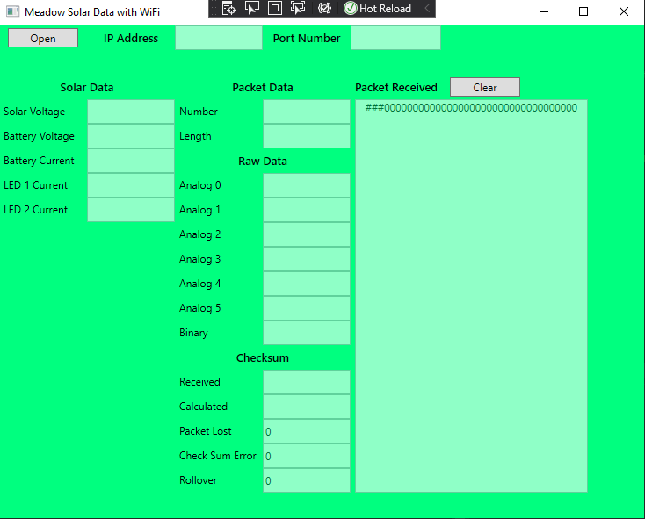

1. Clear display of all data and controls. Properly formatted numerical data. Data and controls clearly labeled. (5 / 5marks)

See demo video.

1. Useful serial input and output. Document below how you used the protocol. Debugging data and count of lost packets can be seen and also hidden. Serial protocol pre-approved and properly document. Checksum used correctly to verify data. (10 / 10marks)

I used UDP over WiFi instead of serial protocol. Sending the same packets that would be sent over serial so the checksum and packet format is the same. The checksum verifies that all the bytes within the packet add up and if not then we have lost a packet.

1. Fully prepare for demo. (5 / 5marks)
   1. Complete this document
   2. Estimate your mark in each section
   3. Charge battery if applicable
   4. Compile and test EXE
   5. ZIP directory of all project file and this doc file
2. Wire your own hardware and wiring must be good quality and safe. Make sure wires cannot be shorted. Shown clearly in demo video. (5 / 5marks)
3. Demo progress each week. (5 / 5marks)
4. Understand all parts of your project and can answer technical questions successfully. (5 / 5marks)
5. Use appropriate OOP style. Use appropriate Event driven programing. Define your classes when appropriate. Explain below how and why you used OOP style, events, classes (9 / 10marks)
6. Bug free code. (8 / 10marks)

Cannot solve the bug where the meadow stops sending out packets randomly between the 10th and 80th packet.

1. Impressive demo video that you can be proud. Clear, concise, and complete. (5 / 5marks)
2. Make a project that highlights your programming skills. Add advanced features that require you to expand your skills. (10 / 10marks)